LEXINGTON Glass Dining Set

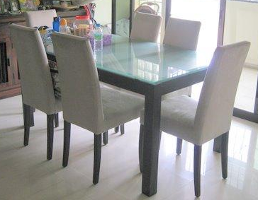

|  |
| --- |
| **DESCRIPTION** |
| LEXINGTON introduces stylish steel dining set with a rich glass glowing finish on top the set of tables and chairs is perfect to create the perfect the lighting surrounding. The rich Polished wood with chemical glass on top gives you feeling of large decorating piece. Perfect for Family Gathering. |

|  |  |  |
| --- | --- | --- |
| **Price** | **1370$** | |
| **Dimensions** | **Table H** x **W** x **L** | **45in x 35in x 45in** |
| **Chairs H** x **W** x **L** | **30in x 24in x 28in** |
| **Features** | **Six Chairs and One Table with hard form covering on each chair provide a great durability for chairs not to lose the pressure and one strong chemical glass protects the table from getting molds** | |
| **Finished** | **Straight Cut Glass Sheet** | |
| **Available in** | **Brown, White, Red and Black** | |